We can use this site <https://sqliteonline.com/> for creating our database. SQLite Browser is in Kali Linux.

**Example 1:**

This is an example of good DNSSEC, [www.novinky.cz](http://www.novinky.cz) (the Czech Republic):

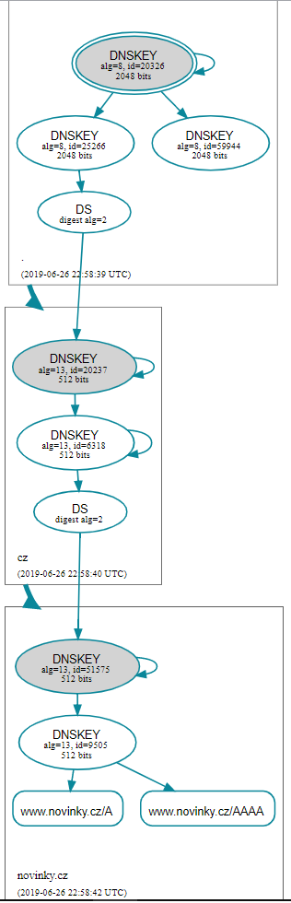

**Example 2:**

This is an example of good DNSSEC, but website [www.kijiji.ca](http://www.kijiji.ca) (Canada) does not use DNSSEC:

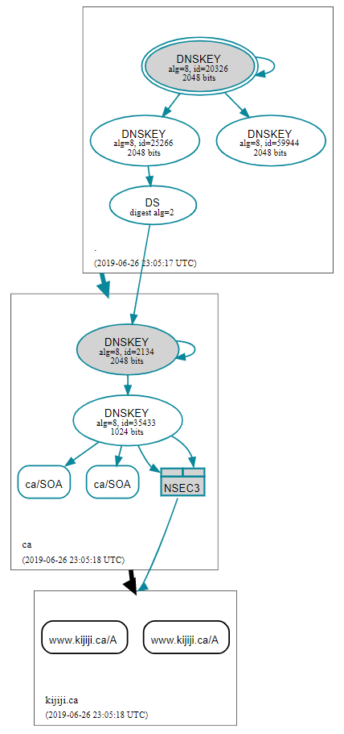

**Example 3:**

This is an example of good DNSSEC, but website [www.bnonline.fi.cr](http://www.bnonline.fi.cr) (Costa Rica) excepts many errors. Therefore command ‘dig +trace’ returns False:

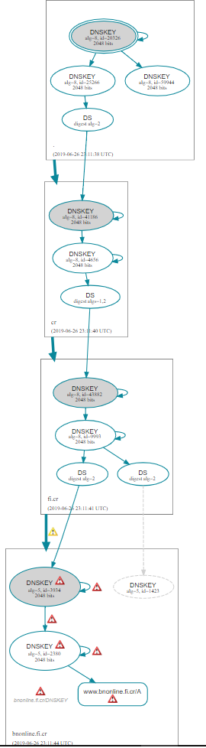

**Example 4:**

This is an example of the Internet country top-level domain does not use DNSSEC, [www.emploi.cg](http://www.emploi.cg) (the Republic of the Congo):

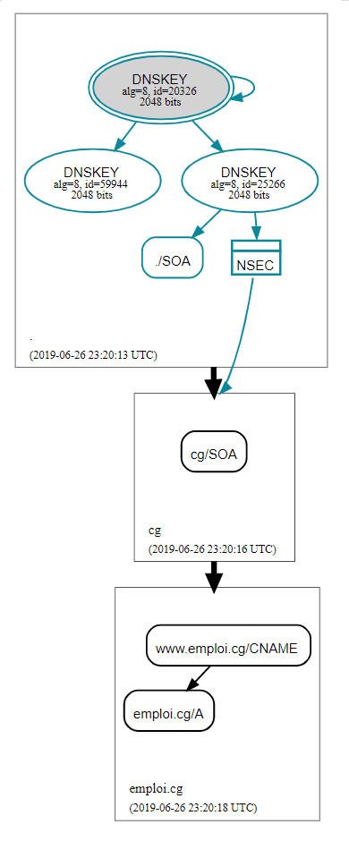

**Example 5:**

This is an example of equal the Internet country top-level domains, but trees are difference.

* Website [www.kohsantepheapdaily.com.kh](http://www.kohsantepheapdaily.com.kh) (Cambodia):

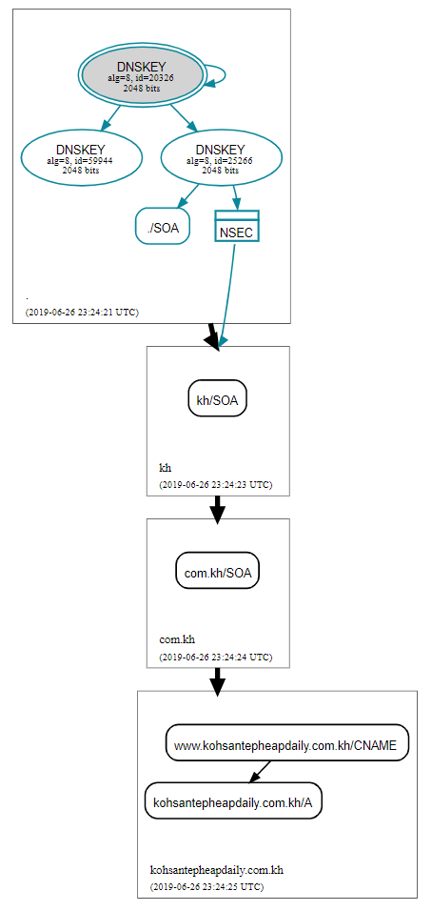

* Website [www.sabay.com.kh](http://www.sabay.com.kh) (Cambodia) has two path and chooses NO DNSSEC path:

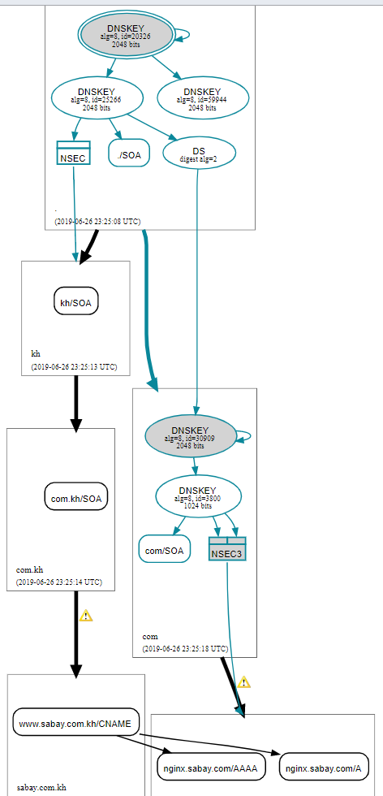

**Example 6:**

This is an example of two path. One uses DNSSEC all the path and the second partially. Website [www.bancoestado.cl](http://www.bancoestado.cl) (Chile) chooses the second path:

